CHAPTER 40
QUANTUM MECHANICS
Discussion Questions

Q40.1 For these macroscopic objects the de Broglie wavelength is exceedingly small and the fact that it is not quite zero is of no consequence. Such objects exhibit no wave properties.

Q40.2 The analogy is sensible.

Q40.3 It is the quantity 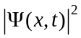 that describes the position of the particle and 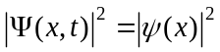 is real even though 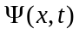 has complex values.

Q40.4 For a one-dimensional system 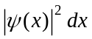 is the probability that the particle will be found in the region x to 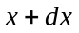. The particle must be somewhere, so 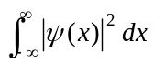 must be unity. But 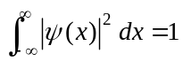 is just the normalization condition. 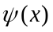 must be normalized if is to be the probability of the particle being found between x and .

Q40.5 No, it just means that the position probability distribution function 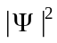 at each point in space doesn’t vary in time. Yes, states of constant energy are stationary states.

Q40.6 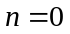 given 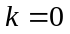 and from Eq.(40.29), 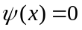. This wave function is a trivial solution to Eq.(40.25) that corresponds to no particle being present. 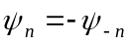 and wave functions differing by a constant describe the same physical state; 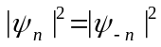 so negative values don’t correspond to additional solutions.

Q40.7 The area under a graph of 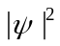 versus between 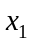 and 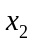 is the probability that a value between and will be found if the position of the particle is measured. The total area under would be unity; there is unit probability that the particle will be somewhere.

Q40.8 The classical particle travels between the walls with constant speed so it is equally probable that it will be found at any . The graph of the probability distribution as a function of would be a horizontal line for 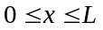 and would be zero for 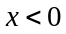 or 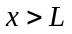. For 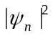 with 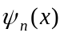 given by Eq.(40.35) the oscillations become very rapid as increases and 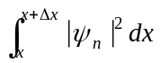 is the same for all intervals 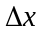. So, yes, the probability distributions approach the classical result as n becomes very large.

Q40.9 Yes, Eq.(40.26) is the form of two traveling waves propagating in opposite directions. The stationary states can be thought of as a standing wave produced by superposition of wave functions for particles traveling in opposite directions due to reflections at the walls of the box.

Q40.10 The wave functions for all states are symmetric about 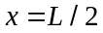 (the center of the box) so the particle is equally likely to be found in either half of the box. The probability of finding the particle in the right half of the box is 1/2, for any level.

Q40.11 The probability of measuring the position of the particle and getting one of these values of is zero. The velocity of the particle is not zero at these points.

Q40.12 . States of definite 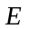 have definiteand definite momentum . But measurements of yields 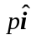 and 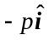 with equal probability so the states of definite energy aren’t states of definite momentum vector.

Q40.13 States of definite energy are not states of definite wavelength and are not states of definite momentum. 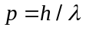 so if doesn’t have a definite value then doesn’t have a definite value. For 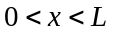, the wave function is a combination of functions 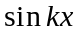and 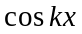 that have definite 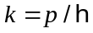. But for and the wave function is of a different form and isn’t characterized by this same .

Q40.14 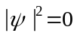 at the walls so there is zero probability that a measurement of the particle’s position yields the values 0 or . But the presence of the walls affects the wave function and energy levels of the particle. If the walls are removed, these quantities change. In this sense the particle strikes the walls.

Q40.15 As Fig.40.14 shows, the wave function extends into the region outside the well and there is some probability for the particle to be found there. From the normalization condition and 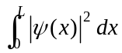 will be less than 1.
Q40.16 Since the wave function extends out into the classically forbidden region ( and ) for the finite well but not for the infinite well (box), the wavelength in a given energy state of the finite well is larger than the wavelength in the corresponding level of the infinite well. 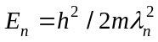 inside the box, so larger means lower energy.

Q40.17 Yes, 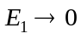 as 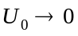. As the wave function extends farther and farther into the and regions. As the momentum approaches zero its uncertainty becomes small, the localization of the particle in becomes less, in accordance with the Heisenberg Uncertainty Principle.

Q40.18 The rate of the exponential decay of the wave function with distance outside the well depends on 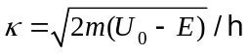. becomes small as 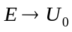. The particle can tunnel farther into the potential barrier when its energy is close to the top of the barrier.

Q40.19 Yes, it is a contradiction. In classical Newtonian mechanics the particle cannot be in this region but in quantum mechanics there is some probability of the particle being there.

Q40.20 The electron density is spherically symmetric so the potential energy function must be spherically symmetric. And the potential energy corresponds to a potential well.

Q40.21 You would expect that for a given particle energy the probability of tunneling would decrease as the barrier height is increased. As the barrier height is increased, 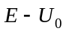 becomes more negative and in classical mechanics it is more strongly forbidden for the particle to be in the barrier.

Q40.22 No. A measurement of the position of the particle gives a definite result. The wave function means that there is some probability that the whole particle can be found in the region 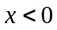 and some probability that the whole particle can be found in the region 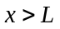.

Q40.23 No. Oscillations in 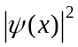 continue to be present. They just get more and more rapid as n increases.

Q40.24 The wave function is smaller in the region 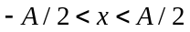 than in the region 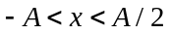 plus 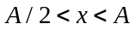. So, even though these two regions are the same size, there is greater probability of finding the particle in the outer half ( plus ) than in the center half (). The particle is more likely to be found near the turning points at 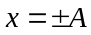 than around 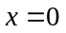. This corresponds to the classical result that 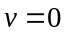 at and that v is a maximum at . The particle spends more time near the turning points.

Q40.25 Harmonic oscillator: 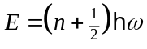. Levels are equally spaced. 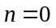 for the ground state. 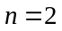for the second excited level.
Particle in a box: 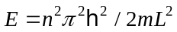. Level spacing increases with increasing n. 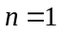for the ground state and 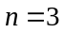 for the second excited level.
Hydrogen atom: 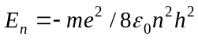. Level spacing decreases with increasing n. for the ground state and for the second excited level.

Q40.26 In either case the wave function is zero at the infinite wall at and is zero for . For 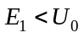 the particle is in a bound level and the wave function exponentially decreases for 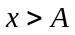 and is zero for 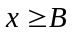. The wave function in the region 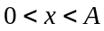 is the wave function for a free particle and will have zero nodes for the ground state and more if it corresponds to an excited state. For 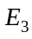 the wave function is zero for 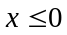 and for . For 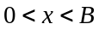 the wave function is that of a free particle and the wave number k is larger in the region than in the region 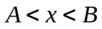. Sketches of the possible wave function for each energy are shown in Fig.DQ40.26.
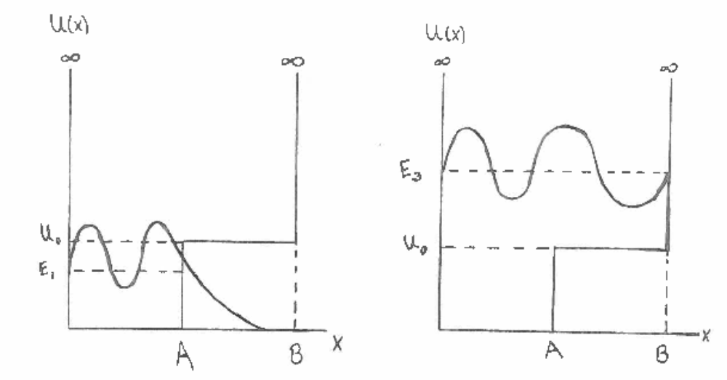
Figure DQ40.26
Q40.27 If the wave function is 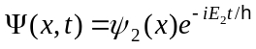, a measurement of the energy yields the value 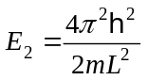. If the wave function is 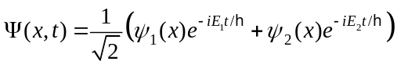, a measurement of the energy can yield either 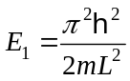 or . There is equal probability of each result so the average result for many measurements with an ensemble of identical particles would be 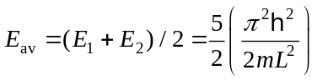. No, we can’t say that before the measurement each particle has energy 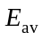. Before the measurement each particle has equal probability of having energy 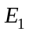 or 

